 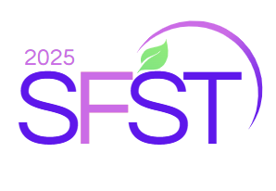

**FIRST NATIONAL SEMINAR ON FOOD SCIENCE AND TECHNOLOGY**

**(October 14-15 2025)**

**Title (Times new roman, font size 14)**

**Presenting Author1**, Co-Authors2,* **(Times new roman, font size 12)**

*Department, Organisation, University, Country* ***(Italic, Times new roman, font size 11)***

*Corresponding Author E-mail: (Times new roman, font size 10) (only one)

**I prefer:** ORAL/ POSTER presentation (choose your preference)

**Topic: ………………………………………….**

**ABSTRACT (Times new roman, font size 12, double-spaced) (Max. 250 words)**

You are invited to submit your abstract (maximum 250 words). Authors whose abstracts are selected will be invited to submit a full paper for peer review. The topics of the seminar includes Food Biotechnology, Nutritional Sciences and Functional Foods, Food Toxicology, Microbiology, and Safety, Food Processing Technologies and Preservation, and Nutrition and Immunity

**Keywords:** Keyword1; Keyword2; Keyword3; Keyword4; Keyword5 (Maximum 5).

**Instructions:**

* This Abstract Template **must be** used for abstract submission
* Abstracts have a maximum of 250 words and **must be** submitted online by September 15, 2025.
* Authors will be notified for abstract acceptance by September 21, 2025.
* Submit abstract via the seminar’s email address: [sfst2025@gmail.com](mailto:sfst2025@gmail.com)
* The topic of your presentation **must be** indicated in the email’s object (l’objet)